**CHAPTER-1**

INTRODUCTION

1.1 INTRODUCTION

The “Digital India” is the Indian Government flagship program with a eyesight and motive to convert India into a Digitally empowered India. “Faceless, Paperless, Cashless” is one of Supposed reason of Digital society. To encourage payment gateways, it has declared discounts on purchases of Certain products online digitally. It has also introduced UPI (United Payment Interface) which is app based To make transactions across multiple banks Government other initiatives like BHIM and UPI are carry in transition and faster adoption of Digital payments. In today’s digitalized era the usage of internet has increased. Now a days the customers are Adopting the digital devices in order to spend less time on banking. We all witnessed how technology have been growing in modern world. Major people who live In urban areas are advanced to this digital payment systems. The Phonepe is a payments App built for India, by the Indians.

1.2 MEANING

PhonePe is a mobile payment platform using which you can transfer money using UPI, recharge phone numbers, pay utility bills, etc. PhonePe works on the Unified Payment Interface (UPI) system and all you need is to feed in your bank account details and create a UPI ID.

●UPI app - UPI payment system allows money transfer between any two bank accounts by using a smartphone. UPI allows a customer to pay directly from a bank account to different merchants, both online and offline. In UPA system to send money, we don't need to give credit card details, IFSC code, net banking passwords etc. The phonePe app is based on the Unified Payment Interface (UPI) platform.

1.3 EVOLUTION

PhonePe is an Indian digital payment and financial technology company headquartered in Bengaluru, Karnataka, India. PhonePe was founded in December 2015, by Sameer Nigam , Rahul Chari and Burzin Engineer.The PhonePe app, supported the Unified Payments Interface (UPI), went sleep in August 2016. PhonePe is licensed by the Reserve Bank of India for issuance and operation of a Semi Closed Prepaid Payment system with Authorisation Number: 75/2014 dated 22 August 2014. PhonePe is accepted as a payment option at over 2.5 crore offline and online merchant.

1.4 ADVANTAGES AND DISADVANTAGES OF PHONEPE:

Phonepe is an all-in-one digital wallet based in India that can be connected to a single debit/credit card or bank account and used for all of your online needs. The UPI-based platform protects any transaction from cybercriminals, keeping users’ financial information secure. So here this article gives the advantages and disadvantages of PhonePe to better understand this topic.

Advantages of PhonePe:

1-PhonePe is a convenient tool for business users. Payment of utility bills, payment of wages, and a payment request from clients can all be done through this app.

2-You can easily set all the utility bill payments like electricity, postpaid mobile bill, landline bill, water tax, house tax, the Insurance premium.

3-This app supports both English and Hindi languages as well as Marathi, Tamil, and Bengali. This makes the app more usable and friendly to operate for all the native who speaks any of that language.

4-Phonepe gives consumers a variety of payment choices to choose from. UPI, bank accounts, credit cards, and debit cards can all be connected to the app, making it a versatile payment system that ensures each source is working properly.

5-The app also offers a much quicker and more reliable form of transaction. The direct transfer of funds from the user’s account to the phone wallet eliminates the need for an account or card linking.

Disadvantages of PhonePe:

1-Because when you tap on the PhonePe app on your mobile, the dashboard opens without any authentication. It neither ask your PIN nor password to open.

2-When you pay with the app, it will appear that processing is still in progress. And it lasts for a long time. Due to technical problems, it can take up to 3 days.

3-It also happens when you pay to a merchant, the message is displayed, payment successful. Your account is also debited for that number, but the receiver account is creditless. In certain cases, credit processing can take up to 24 hours. It frequently causes you emotional distress.

4-The ticket should be booked through the phone app the problem arises when there is a refund issue of the cancelled ticket.5-Phonepe does not give you interest in your wallet deposit. Other UPI apps that have wallet facilities do not give interest as well.

**CHAPTER-2**

REVIEW OF LITERATURE

2.1 → REVIEW OF LITERATURE

• Satinder Bal Gupta R. K. (2020). The use of Electronic Payment is increasing at a very fast rate.day by day the numbers of users are moving towards online payment system instead of the using plastic money like cash etc. Making online transactions is very convenient and time savings. People can pay online not only for shopping but also for different purpose as many different apps are available that offers many services to the users. The paper studies the reasons of increasing popularity and use of the payment apps by people of India for making the Payments online and the continuous growth of these payment apps in India. The authors of this paper analysed three most popular payment Apps used in India namely, Google pay, phonepe and Paytm etc

• Dr.S. Poongodi, D.P.(2021). Digital payment systems is gaining popularity due to the"DIGITAL INDIA" compagin introduced by the government of India. They are various forms of digital payment system. Simple percentage, Weighted Average Percentage, Weighted Average Ranking and Chi-square test have been used to analyze the data. The study reveals that majority of the customers are females with the age of below 30 years, and majority of them are undergraduates employed in private sector with an earning of up to Rs.20,000 per month and they are aware about phonepe through friends, relatives and by themselves. The reasons for using phonepe are mobile recharge followed by payments of the EMI, DTH recharge etc

• Saviour F (2019). In the study analysed the various factors which results in consumer satisfaction. The researchers main focus is on the satisfaction level of Paytm users Researcher has identified the explanations for dissatisfaction of consumer towards the wallets of service and also the reasercher made an effort to seek out suggestions economy.

• Abhijit and Harmeet (2017). studies about the phone pay usage by smartphones users and also attempts to analyse the various the varied obstacles faced by the phonepe users.

●Handelsman and Munson(1989), “Switching behaviours from credit card to cash payments among ethnically diverse retail customers” shows that the credit card sales constitute an important revenue source for many retailers. Their ever increasing use and evaluation into other forms, such as debit and electron cards, demands that retailers gain a more complete understanding of how they are used by diverse consumer segments. Particularly needed is a better understanding of the propensity to switch over from credit card to cash payment and the incentive required to initiate switching. In view of the cost to the retailer of administering credit card payment systems, the retailers overall profits position may be enhanced by converting a larger proportion of credit card sales to cash sales. Four aspects of credit card usage and switching ethnicities are investigated, propensity to switch over from credit card to cash payment at various levels of monetary incentive, the effect of product price on propensity to switch, the frequency of credit card usage, and the preffered method of payment of credit card balances. Several significant differences are shown among the ethinic groups studied(ANGLO-AMERICAN, ChinesPhonePe American and his panic-American) in these usage behaviours such differences might even be extended to international comparisions involving consumers domiciled in different countries.

●Barker (1992) in his study, globalisation of credit card usage: The case of a developing economy” investigate the attitude of Turkish consumers towards credit cards, and the approach of card issuers by surveying to samples of 200 card holders and non holders. The better educated, middle aged members of the upper middle class seem to be the prime target; the most important reasons for using the credit card were “case of payment”, followed by “Risk of carrying cash”, Non holders don’t carry credit cards because they do not know much about it: Informal sources of information appear to be more influential that mass media advertising in penetrating the market; Proposes that the usage and the administration of credit cards are influenced very much by the infrastructure of the country and hence, Credit card companies have to modify their marketing and administrative procedures rather than following a standardised approach.

●Natarajan and Manohar(1993) “Credit card-An Analysis”. A study has been attempted to know that to what extent the creadit cards are utilized by the card holders and the factors influencing the utilization of credit cards. The study is confined to cards issued by the canara bank. A random sampling technique is used to collect the data. 10 componenets i.e. Number of purchases, shops, percentage of purchases, place, frequency, type of product type of services, cash withdrawal facilities, add on facility insurance, schemes are identified and used for further measurements. Chi Square test reaveals that sex, age, education qualification of card holders has now relationship with utilization of can card.While occupation, income, employment status of sports, mode of getting card has relationship with utilization of can card.

●Mobile payments constitute a natural evolution of electronic payments (Mallat, 2007). One of the first mobile payment solutions was introduced by the Finnish company Sonera in 1997, which allowed purchasing soft drinks at vending machines using mobile phones

●(Dahlberg et al., 2003). Soon after, the number of mobile payment providers and their offerings have rapidly increased. Google introduced its Wallet app in 2011, while Apple launched Apple Pay in 2014. In Finland, the most popular solutions in 2016 were MobilePay and PayPal Mobile (Statista, 2016). In 2017, two major services, Siirto and Apple Pay, were introduced.

●Mobile payment is defined as a process whereby money is transferred through a mobile device from the payer to the receiver (Mallat, 2007). The mobile device refers to a smartphone, mobile phone or personal digital assistant (Kim et al., 2010). Mobile payments use wireless communication technologies, for example mobile telecommunication networks (Kim et al., 2010). Mobiles are used for bill payment, account transfers, peer-to-peer transfers, proximity and remote payments, discounts, mobile marketing or ticketing (Oliveira et al., 2016). Mobile payments can substitute all major payment methods including cash, credit and debit cards, and electronic bill payments (Dahlberg et al., 2003). Schierz et al. (2010) outline the common definitions of mobile payment process; some authors refer to two phases of the process, namely authorization and initiation, while others also add realization of the payment. It is important to note the difference between mobile payment and mobile banking (Mallat, 2007). Although sometimes treated interchangeably, the former involves a process between the customer, bank and the merchant, while the latter relates toa customer-bank relationship (Oliveira et al., 2016).

●The literature displays no consensus on a generic mobile payment categorization; different classifications exist based on different criteria. The mobile payment services are divided into for example in-app, mobile web and in-store payments (Hillman and Neustaedter, 2017). The former involves conducting transactions via mobile applications; H&M is an example of store allowing in-app payments. Shopping through mobile web requires Internet access; the consumer opens the store browser on his/her phone, selects products and finalises the payment. Finally, payments made in physical stores most

●commonly involve building a connection between the customer’s mobile phone and payment terminal. Mobile payments can be also split into two broad categories: bill payments and everyday purchases (Dahlberg et al., 2008) or into three groups: person-to-person money transfers, payments made on the mobile web and mobile transactions conducted at the pointof-sale (POS) (Hayashi, 2012). Falk et al. (2016) also refer to the point-of-sale to classify mobile payments, while adding equipment as another criterion. According to Falk et al. (2016), mobile payments can be made dependently or not from the point-of-sale (POS) and by using hardware or software; software-based solutions require downloading a mobile app,

●while hardware-based solutions demand the use of equipment, most commonly in the form of a NFC chip (Falk et al., 2016). POS-dependent payments require the common presence of shopper and merchant, while for POS-independent solutions their location can be different. Within POS-independent payments, the most common are software-based money transfer solutions, for instance PayPal (Falk et al., 2016). Many POS-dependent solutions integrate both software and hardware; for example, Samsung Pay users need the app (software) and the phone equipped with the magnetic secure transmission (MST) technology, which makes connection with the store’s terminal (hardware).

●The mobile payment process consists of multiple stages and varies among service providers. A basic model summarizing the most common stages

●Overall, the processes may be divided into two main parts: payment app setup and payment finalization at the POS. The former involves downloading the desired app or finding it onthe mobile system; many services for example Apple Pay or Samsung Pay are pre-installed

●on the relevant platforms (Haselton, 2017). Setting up also involves adding card details either manually or via mobile camera. At this stage, some applications ask users to verify themselves; for instance, Samsung Pay requires scanning one’s iris or fingertips and entering a personal identification number (PIN). After the mobile payment is set up it can be used instore. The customer must ensure the contactless payment symbol or app’s icon is present at the POS; not all terminals accept mobile payments. Further verification is then performed, for instance the Apple Pay service requires placing the finger on the fingerprint scanner, while

Samsung Pay allows verification with PIN or biometrics. Finally, the phone is hold near the reader screen to build the connection with the terminal and process the payment. Once the transaction is completed, the customer receives a confirmation message.

**CHAPTER-3**

RESEARCH METHODOLOGY

3.1 OBJECTIVES OF THE STUDY

→ To understand the concept of phonepe → To analyze the customer satisfaction by the usage of PhonePe → To know the awareness of the services provided by the phonepe

## 3.2 NEED FOR THE STUDY

→ Now a days as the approach for online shopping is increasing people are getting used to online payments as they are being the unique solution for cashless payments.

→ This study contributes valuable things like the consumer behaviour towards the usage of Phonepe

→ The benefits and safety of using Phonepe.

→ The consumer satisfaction by the usage of Phonepe.

→ The importance of Phonepe among the customers.

3.3 SCOPE OF THE STUDY

→ The aim of the study is to determine consumer satisfaction by using Phonepe

→ The scope of the study is confined to only 117 respondents

→ Enhance acceptance infrastructure in the country to promote digital transactions

3.4 RESEARCH METHODOLOGY

This studied have been carried out on Phonepe Payment System. Data used in this study collected basically from the secondary sources. Primary data also collected through personal interview method conducting the person who is supposed to have knowledge about the topic. Secondary data have been collected from various sources including websites, newspapers, various published and unpublished article about phonepe primary education etc.

3.5 METHOD OF DATA COLLECTION

→ SURVEY INSTRUMENT:

Questionnaire sent to the person concerned with request to answer the questions and return the questionnaire. The questionnaire is sent to respondent who expected to read and understand the question and write down the reply in the space meant for the purpose in questionnaire itself. A questionnaire consists of a number of questions typed in a definite order on a form. The respondent to have answered the questions on their own. Objective type questions have been designed in survey. Some responses have been collected from people. Like ( student, employee and others). The result of survey shown in graphs. The questionnaire designed on phonepe Payment System.

**→ Data Collection:**

The data collected were analyzed for the entire sample.

**→ Result:**

This is a descriptive research which has studied the present conditions. The relevant data was collected based on phonepe system and which phonepe payment type of most suitable.

3.6 → SOURCES OF DATA

▪ Primary data: Primary data is collected for the first time . It is collected through googleforms which consist of multiple choice questions.

▪ Secondary data: Secondary data is used to obtain information regarding Phonepe. It is used whenever needed.

(A) SAMPLE SIZE

▪ Sample size is 117.

(B) SAMPLING TECHNIQUE :

▪ Simple questionnaire is drafted with 16 multiple choice questions which is shared to 117 respondents through google forms.

▪ Simple statistical tools like percentage pie charts are used to analyse and interpret the data.

3.7 LIMITATIONS OF THE STUDY

• The time for the study is limited to only 1 and half month.

• Accuracy of data depends upon the information provided by the respondents.

• The survey is limited to only 117 people.

**CHAPTER-4**

COMPANY PROFILE & INDUSTRY PROFILE

4.1 INDUSTRY PROFILE

A mobile wallet is a type of online wallet that reserves credit card numbers, debit card numbers and loyalty card numbers. It is reachable through an app installed on a mobile device, such as a Androids or tablets.

Penetrable Mobile Wallets

The information stockpile in a mobile wallet is encoded, making it tough for cybercriminals to implement fraudulent activities with them. While physical credit and debit cards can be stolen or duplicated, Mobile Wallets are hard to steal since they come with encrypted keys that may not disclose any useful information.

Once a consumer installs a mobile wallet on their mobile/android device, they are required to dispense their credit card details, reward cards and coupons. The details is then linked to an accepted personal identification format, such as a key or a scannable QR code.

When a consumer makes an in-store remittance, the mobile app uses near-field passing on (NFC Technology) to presenting between devices, The NFC uses a QR code, key or another personal recognition format to process the settlement at the payment terminal. The action is set going when the user taps or waves the NPC-sanction device at the merchant's point-of-service terminal.

1. Open wallets

2. Closed wallets

3. Semi-closed mobile Wallets

When making an in-store purchase, discover merchants that agree to receive your chosen payment gateway, Usually, merchants that permit mobile wallet payments can be find through a contactless payment indicator (usually a sideways WI-FI symbol).

When making a payment, consumers are required to tap or wave their device to the NFCenabled terminal. After making the remittance, a message is sent to the dealer regarding the payment. The merchant must honor the message alert for the payment to be convey from the users account to the merchant's account.

4.2 COMPANY PROFILE

The “Digital India” is the Indian Government flagship program with a eyesight and motive to convert India into a Digitally empowered India. “Faceless, Paperless, Cashless” is one of Supposed reason of Digital society. Digital payment system has gained a lot of importance nowadays, especially after Demonetization and also at the time of Covid-19. The government is taking steps to encourage the people in the society to use payments Gateway platforms.

To encourage payment gateways, it has declared discounts on purchases of Certain products online digitally. It has also introduced UPI (United Payment Interface) which is app based To make transactions across multiple banks .Another improved version is set to be disclosure by the Government, which makes banking transactions through mobile phones without internet by a Service called USSD(Unstructured Supplementary Service Data). These lead have provided extensive boost up to the digital payment system in the country.

Government other initiatives like BHIM and UPI are carry in transition and faster adoption of Digital payments. Electronics Consumer transactions made at point of sale (POS) for services and Products either through internet banking or mobile banking using smart phone or debit or credit card payment are Called as digital payment.

In today’s digitalized era the usage of internet has increased. Now a days the customers are Adopting the digital devices in order to spend less time on banking. This digital payments is very Useful to transaction funds without taking any risk and also easy to make and handle use of it.

We all witnessed how technology have been growing in modern world. On This case the online Digital payment apps also introduced and it has been successful among customers .Major people who live In urban areas are advanced to this digital payment systems. Unless very low number of people who Lives in rural areas still didn’t know the importance and services provided by the online payment apps .

Over the next decade, digital payments are going to become more accessible to the next billion users.

The Phonepe is a payments App built for India, by the Indians.

PhonePe is an Indian digital payment and financial technology company headquartered in Bengaluru, Karnataka, India. PhonePe was founded in December 2015, by Sameer Nigam , 7 Rahul Chari and Burzin Engineer.The PhonePe app, supported the Unified Payments Interface (UPI), went sleep in August 2016. It is owned by Flipkart, a subsidiary of Walmart.

PhonePe has 4 investors which includes Tiger Global Management And Tencent.

Over the next decade,digital payments are going to become more accessible to the next billion users and it’s goal is to facilitate this change by building payment solutions for it’s user base.

The PhonePe app is on the market in 11 Indian languages. Using PhonePe , users can send and receive money, recharge mobile, DTH , data cards, make utility payments, pay at shops, invest in tax saving funds, liquid Funds, buy insurance, mutual funds, gold, and silver. Additionally PhonePe also allows users to book their Ola rides, pay for Redbus tickets, book flights and hotels on Goibibo through the Switch platform.

PhonePe is accepted as a payment option at over 2.5 crore offline and online merchant outlets across 15,700 towns and villages.The app crossed 10 crore user mark in June 2018 and also crossed 500 crore transactions in December 2019. It currently has over 35 crore registered users with over 15 crore monthly active users.

PhonePe is licensed by the Reserve Bank of India for issuance and operation of a Semi Closed Prepaid Payment system with Authorisation Number: 75/2014 dated 22 August 2014.

In April 2016, the corporate was acquired by Flipkart and as a component of the Flipkart acquisition, the FxMart license was transferred to PhonePe and it had been rebranded because the PhonePe wallet. PhonePe 's founder Sameer Nigam was appointed as the CEO of the corporate.

In August 2016, the corporate partnered with Yes Bank to launch a UPI-based mobile payment app, supported the government-backed UPI platform.

Within 3 months of launch, the app was downloaded by over 1 crore users. In 2018, PhonePe also became the fastest Indian payment app to urge a 5 crore badge on the Google Play Store. The PhonePe app overtook BHIM to emerge because the market leader in UPI transactions in August 2017.

Adoption of cashless transaction has been significantly pushed after demonetization of high value currency of Rs 500 and 1000. The demonetization resulted in unprecedented growth in digital payment. The simplest advantage of using an e-payment app is customer convenience as they're going to be able to make payments using their mobile phones either using the 8 contactless payments or by scanning QR code instantly. Most of the time, these apps use either encrypt or Codes to minimize the threat to the personal data of customers and also they go without cash everywhere where they want to go.

The use of these e -payment apps Provides its users with coupons, discounts, rewards,points, and so on. The introduction Of e-payment app has improved the cash flow in the society. There are lot of e-payment appS such as Airtel Money, Amazon Pay, Free charge, Google Pay, JIO Money, Paytm, Phonepe, etc.

|  |
| --- |
| PhonePe  Company: phonepe.com  Founded: 2015  CEO: Sameer Nigam (Dec 2015–)  Headquarters: Bengaluru  Users: 35 crore  Available in: Multilingual (11)  Parent organization: Flipkart  Founders: Sameer Nigam, Rahul Chari, Burzin Engineer |

**CHAPTER-5**

DATA ANALYSIS & INTERPRETATION:

TABLES, GRAPHS

5.1 INTRODUCTION:

The current research project is the study of customer satisfaction by the usage of PHONEPE.

I prepared a google form which consist of 16 multiple choice questions and taken 117 respondents who belong to Telangana. A simple structured questionnaire is issued, and simple statistical tools like pie chart has been used to draw conclusions.→ TABLE 5.1: 1 AGE

|  |  |  |
| --- | --- | --- |
| OPTIONS | NO.OF RESPONDENTS | PERCENTAGE OF RESPONDENTS |
| Below18 | 7 | 6% |
| 18-25 | 69 | 58.6% |
| 25-40 | 28 | 24.1% |
| 40 and above | 13 | 11.2% |
| TOTAL | 117 | 100 |

SOURCE: PRIMARY SOURCE

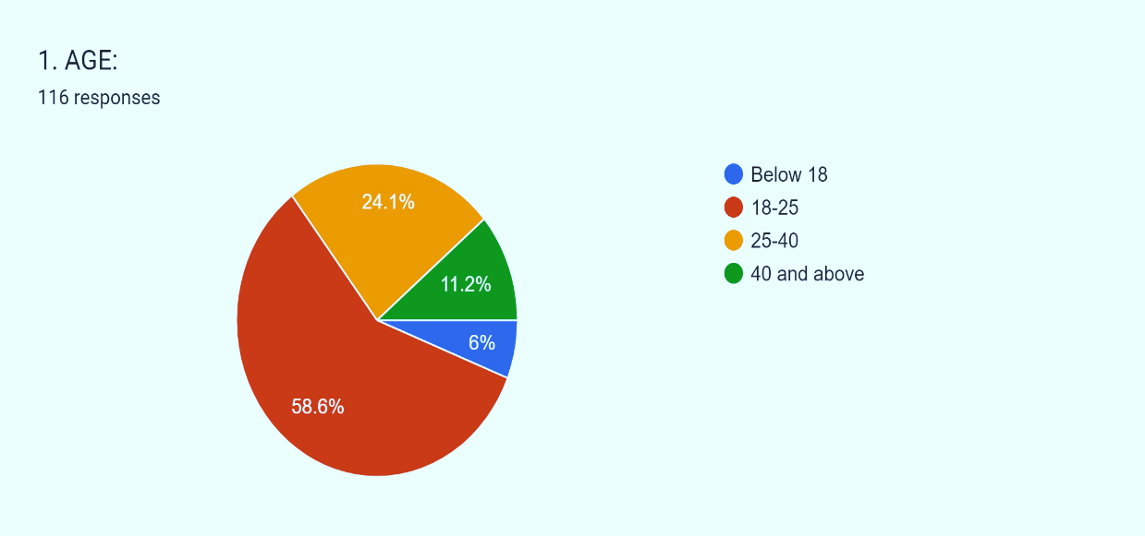

INTERPRETATION:

From the above table it is observed that below 18 age group are 6%, 18-25 age group are 58.6%, 25-40 age group are 24.1%, 40 and above age group are 11.2%

→ TABLE 5.2: 2 GENDER

|  |  |  |
| --- | --- | --- |
| OPTIONS | NO.OF RESPONDENTS | PERCENTAGE OF RESPONDENTS |
| FEMALE | 73 | 62.1% |
| MALE | 44 | 37.9% |
| TOTAL | 117 | 100% |

SOURCE: PRIMARY SOURCE

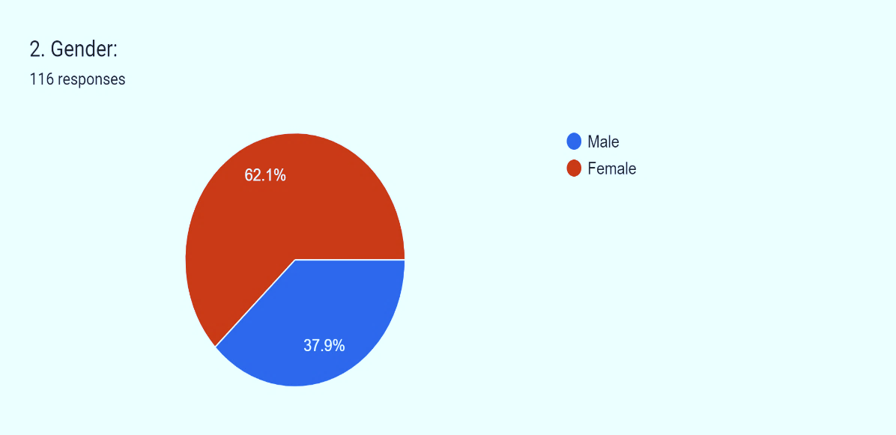

INTERPRETATION:

From the above table it is observed that 62.1% of the respondents are female, and the rest 37.9% of respondents are male.

→ TABLE 5.3: 4 OCCUPATION

|  |  |  |
| --- | --- | --- |
| OPTIONS | NO.OF RESPONDENTS | PERCENTAGE OF RESPONDENTS |
| STUDENT | 54 | 45.7% |
| EMPLOYEE | 45 | 38.8% |
| BUSINESS | 7 | 6% |
| OTHERS | 11 | 9.5% |
| TOTAL | 117 | 100 |

SOURCE: PRIMARY SOURCE

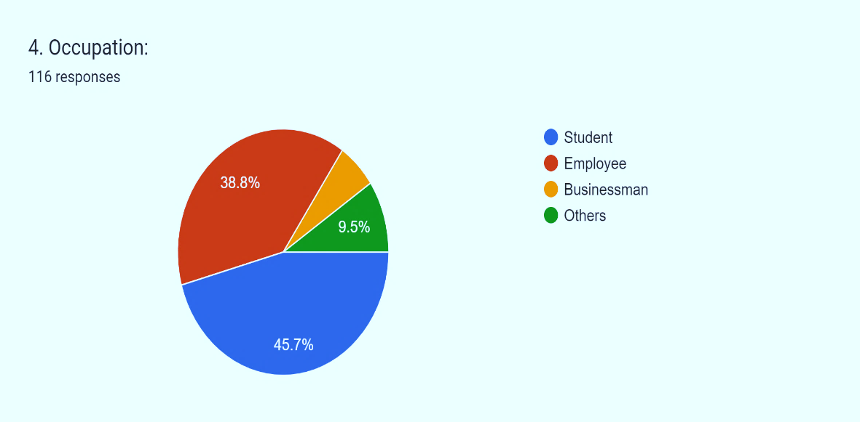

INTERPRETATION:

From the above table it is observed that 45.7% of respondents are students, 38.8% are employees, 6% are business, and the rest 9.5% belong to other occupations.

→ TABLE 5.4: 5 DO YOU USE PHONEPE

|  |  |  |
| --- | --- | --- |
| OPTIONS | NO.OF RESPONDENTS | PERCENTAGE OF RESPONDENTS |
| YES | 115 | 98.3% |
| NO | 2 | 1.7% |
| TOTAL | 117 | 100% |

SOURCE: PRIMARY SOURCE

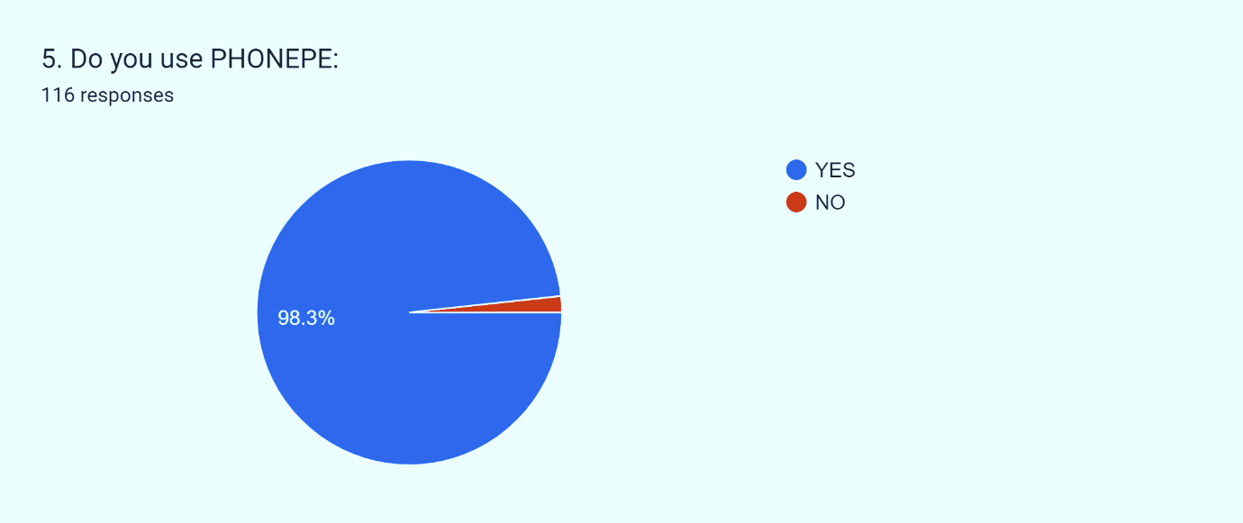

INTERPRETATION:

From the above table it is observed that 98.3% of respondents use phonepe whereas remaining 1.7% of respondents doesn’t use phonepe.

→ TABLE 5.5: 6 HOW LONG HAVE YOU BEEN USING PHONEPE

|  |  |  |
| --- | --- | --- |
| OPTIONS | NO.OF RESPONDENTS | PERCENTAGE OF RESPONDENTS |
| BELOW 1 YEAR | 20 | 16.5% |
| 1-3 YEARS | 57 | 49.6% |
| ABOVE 3 YEARS | 39 | 33.9% |
| TOTAL | 116 | 100% |

SOURCE: PRIMARY SOURCE

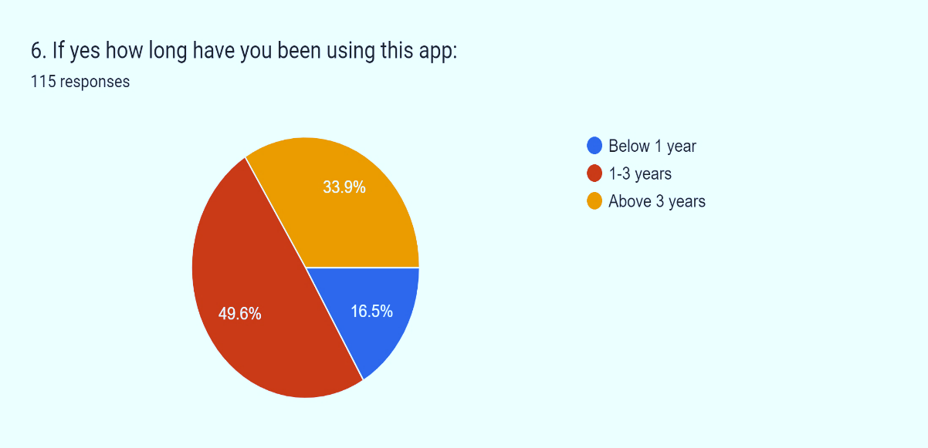

INTERPRETATION:

From the above table it is observed that 16.5% of respondents are using phonepe since below 1 year, 49.6% of the respondents are using since 1-3 years, and 33.9% of respondents are using it since above 3 years.

→ TABLE 5.6: 7 HOW OFTEN DO YOU USE THIS APP

|  |  |  |
| --- | --- | --- |
| OPTIONS | NO.OF RESPONDENTS | PERCENTAGE OF RESPONDENTS |
| DAILY | 52 | 45.2% |
| WEEKLY | 35 | 30.4% |
| OCCASIONALLY | 29 | 24.3% |
| TOTAL | 116 | 100% |

SOURCE: PRIMARY SOURCE 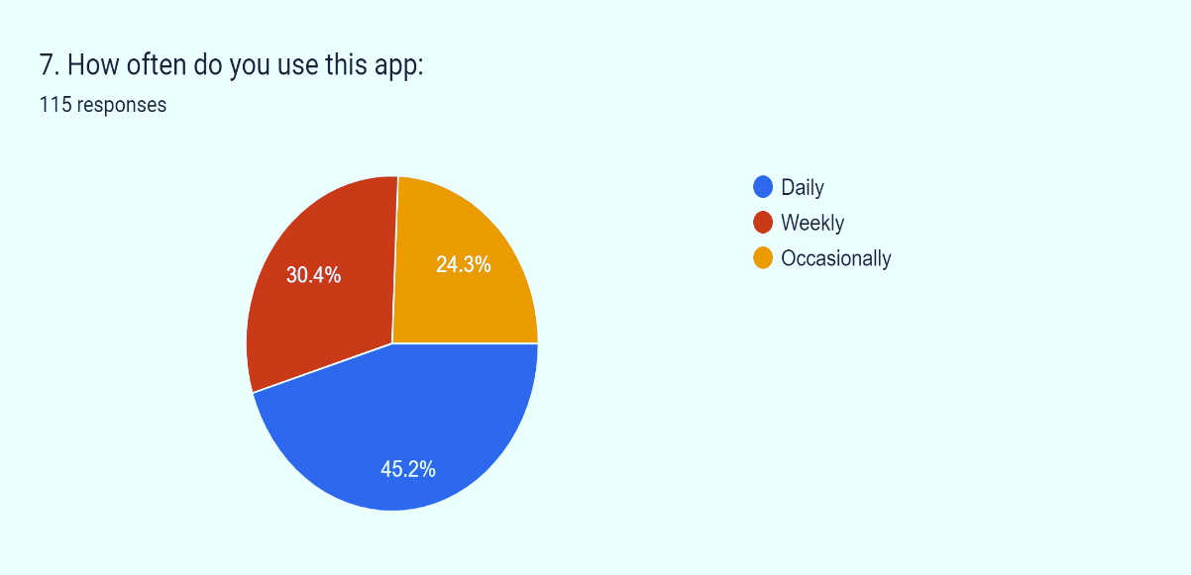

INTERPRETATION:

From the above table it is observed that 45.2% of respondents use phonepe daily, 30.4% of respondents use weekly, and 24.3% of respondents use occasionally.

→ TABLE 5.7: 8 WHAT PAYMENTS DO YOU PREFER TO MAKE USING PHONEPE

|  |  |  |
| --- | --- | --- |
| OPTIONS | NO.OF RESPONDENTS | PERCENTAGE OF RESPONDENTS |
| BILL PAYMENTS | 10 | 8.7% |
| FUND TRANSFER | NIL | NIL |
| SHOPPING | 20 | 16.5% |
| ALL OF THE ABOVE | 86 | 74.8% |
| TOTAL | 116 | 100% |

SOURCE: PRIMARY SOURCE

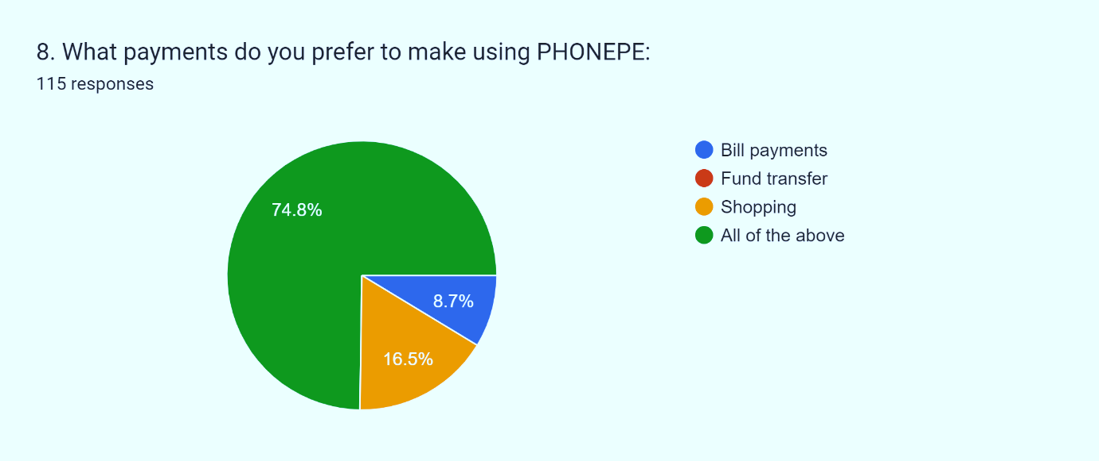

INTERPRETATION:

From the above table it is observed that 8.7% of the respondents use phonepe for bill payments, 16.5% for shopping and rest 74.8% used phonepe for all of the above payments.

→ TABLE 5.8: 9 DID YOU EVER TRY QR PAYMENTS IN PHONEPE

|  |  |  |
| --- | --- | --- |
| OPTIONS | NO.OF RESPONDENTS | PERCENTAGE OF RESPONDENTS |
| YES | 113 | 98.2% |
| NO | 2 | 1.8% |
| TOTAL | 115 | 100% |

SOURCE: PRIMARY SOURCE

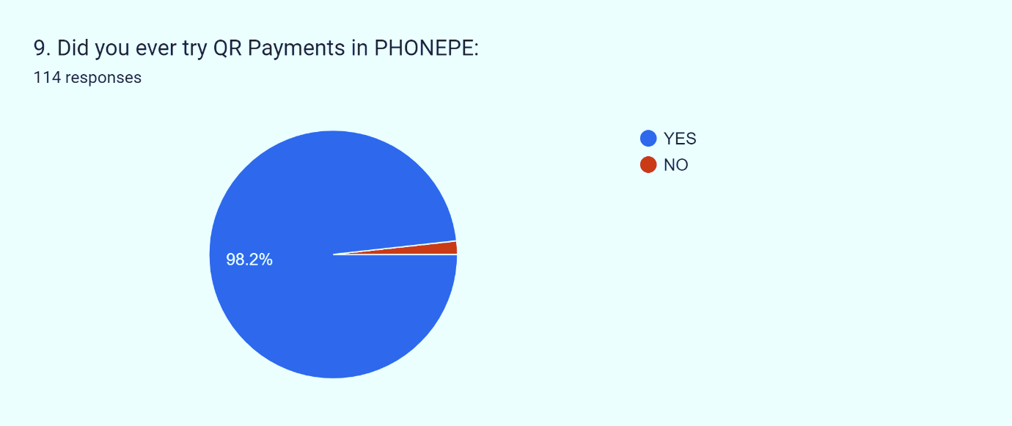

INTERPRETATION:

From the above table it is observed that 98.2% of the respondents tried the QR payments and the rest 1.8% of respondents didn’t try QR payments.

→ TABLE 5.9: 10 IF YES WHY DO YOU PREFER QR PAYMENTS

|  |  |  |
| --- | --- | --- |
| OPTIONS | NO.OF RESPONDENTS | PERCENTAGE OF RESPONDENTS |
| CONVENIENT | 26 | 22.8% |
| EASILY AVAILABLE | 19 | 16.7% |
| SECURE | 19 | 16.7% |
| ALL OF THE ABOVE | 51 | 43.9% |
| TOTAL | 115 | 100% |

SOURCE: PRIMARY SOURCE

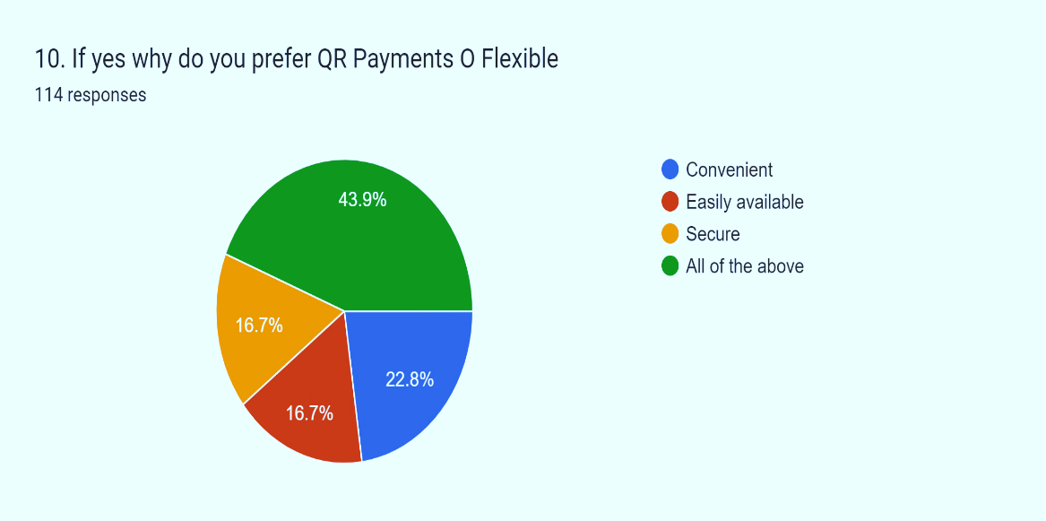

INTERPRETATION:

From the above table it is observed that 22.8% of the respondents used QR because it is convenient, 16.7% because it is easily available, 16.7% because it is secure, and the rest 43.9% because of all of the above reasons.

→ TABLE 5.10: 11 DID YOU FACE ANY TROUBLE WHILE USING PHONEPE FOR PAYMENTS

|  |  |  |
| --- | --- | --- |
| OPTIONS | NO.OF RESPONDENTS | PERCENTAGE OF RESPONDENTS |
| YES | 111 | 95.7% |
| NO | 5 | 4.3% |
| TOTAL | 116 | 100 |

SOURCE: PRIMARY SOURCE

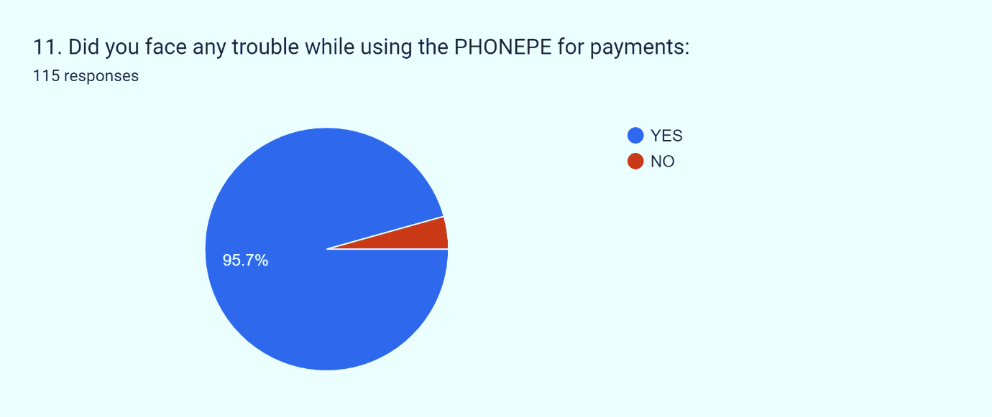

INTERPRETATION:

From the above table it is observed that 95.7% of the respondents faced trouble while making payments using phonepe, and the rest 4.3% of respondents didn’t face trouble while making payments using phonepe.

→ TABLE 5.11: 12 IF YES WHAT TYPE OF TROUBLES DID YOU FACE

|  |  |  |
| --- | --- | --- |
| OPTIONS | NO.OF RESPONDENTS | PERCENTAGE OF RESPONDENTS |
| TECHNICAL ISSUES | 28 | 24.3% |
| DELAYED PAYMENTS | 23 | 19.1% |
| REFUND ISSUES | 27 | 23.5% |
| ALL OF THE ABOVE | 38 | 33% |
| TOTAL | 116 | 100% |

SOURCE: PRIMARY SOURCE

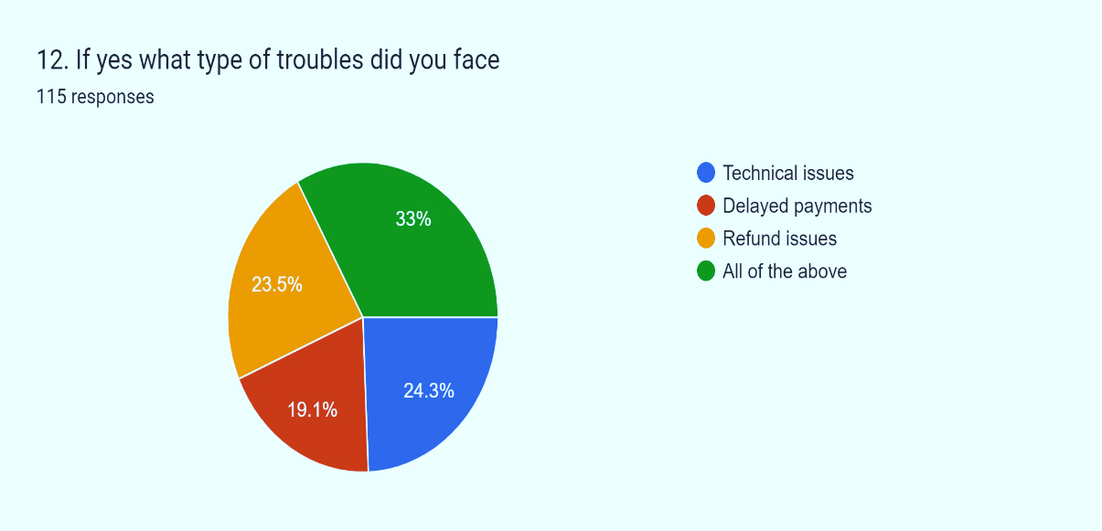

INTERPRETATION:

From the above table it is observed that 24.3% of respondents faced technical issues, 19.1% delayed payments, 23.5% of refund issues, and the rest 33% faces all the above problems.

→ TABLE 5.12: 13 ARE YOU SATISFIED WITH THE SERVICES PROVIDED BY THE PHONEPE

|  |  |  |
| --- | --- | --- |
| OPTIONS | NO.OF RESPONDENTS | PERCENTAGE OF RESPONDENTS |
| YES | 114 | 98.3% |
| NO | 2 | 1.7% |
| TOTAL | 116 | 100% |

SOURCE: PRIMARY SOURCE

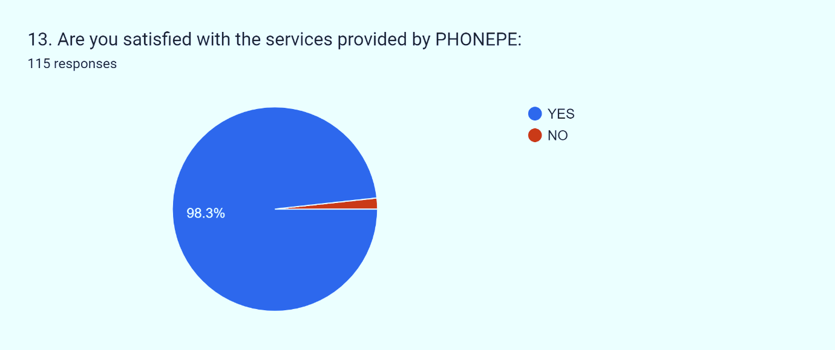

INTERPRETATION:

From the above table it is observed that 98.3% of the respondents are satisfied with the services provided by the phonepe, and the rest 1.7% of respondents are not satisfied with the services provided by the phonepe.

→ TABLE 5.13: 14 ARE YOU AWARE OF OTHER SERVICES AVAILABLE IN PHONEPE

|  |  |  |
| --- | --- | --- |
| OPTIONS | NO.OF RESPONDENTS | PERCENTAGE OF RESPONDENTS |
| YES | 105 | 90.4% |
| NO | 11 | 9.6% |
| TOTAL | 116 | 100% |

SOURCE: PRIMARY SOURCE

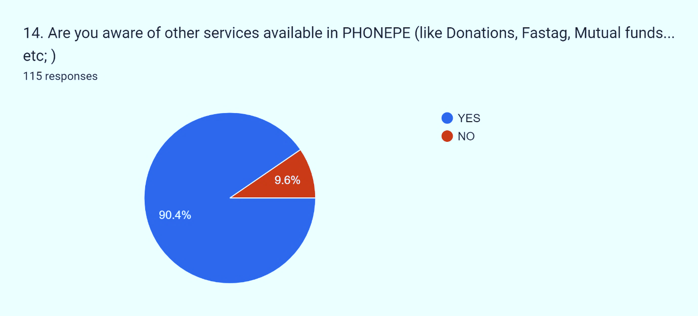

INERPRETATION:

From the above table it is observed that 90.4% of the respondents are aware of other services provided by phonepe, and the rest 9.6% of respondents are unaware of the services provided by the phonepe.

→ TABLE 5.14: 15 DO YOU SUGGEST PHONEPE TO OTHERS

|  |  |  |
| --- | --- | --- |
| OPTIONS | NO.OF RESPONDENTS | PERCENTAGE OF RESPONDENTS |
| YES | 108 | 93.9% |
| NO | 7 | 6.1% |
| TOTAL | 115 | 100% |

SOURCE: PRIMARY SOURCE

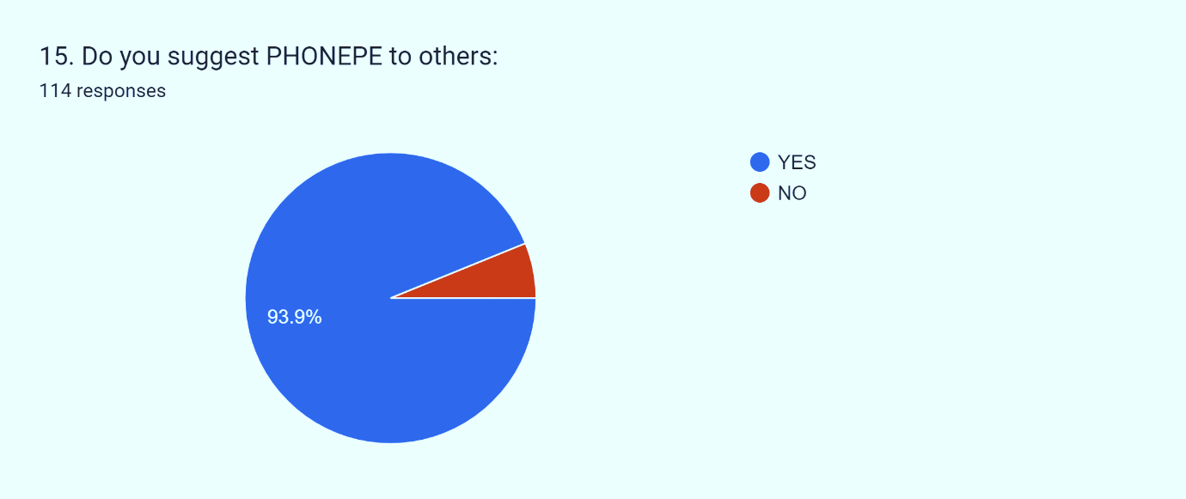

INTERPRETATION:

From the above table it is observed that 93.9% of the respondents are ready to suggest phonepe to others, and the rest 6.1% respondents are not ready to suggest phonepe to others.

→ TABLE 5.15: 16 HOW WOULD YOU RATE PHONEPE APP ON A SCALE OF 1-5

|  |  |  |
| --- | --- | --- |
| RATINGS | NO.OF RESPONDENTS | PERCENTAGE OF RESPONDENTS |
| 1 | 2 | 1.7% |
| 2 | 0 | 0% |
| 3 | 10 | 8.5% |
| 4 | 84 | 72.6% |
| 5 | 20 | 17.1% |
| TOTAL | 116 | 100% |

SOURCE: PRIMARY SOURCE 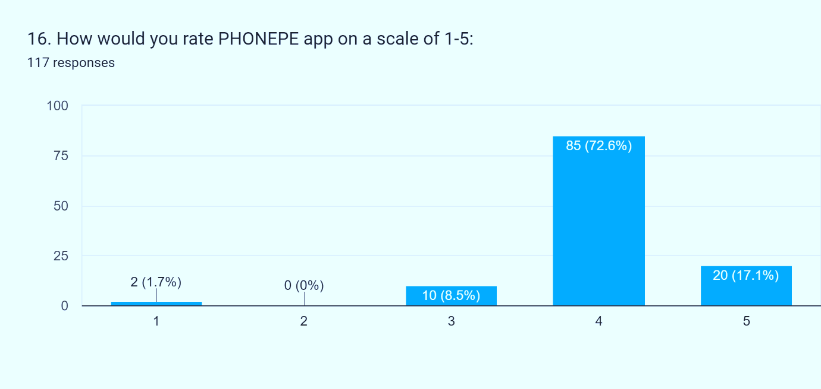

INERPRETATION:

From the above table it is observed that 1.7% of respondents rated 1 star, 0% respondents rated 2, 8.5% rated 3, 72.6% rated 4, and the rest 17.1% rated 5.

5.16 **TABLE NAME**

→ OCCUPATION AND RATING OF PHONEPE ON A SCALE OF 1-5

|  |  |  |  |  |  |
| --- | --- | --- | --- | --- | --- |
| Occupation/Rate phonepe app on a scale of 1-10 | 1 | 3 | 4 | 5 | Grand Total |
| Businessman | - | - | 6 | 1 | 7 |
| Employee | - | 4 | 36 | 3 | 43 |
| Others | - | 1 | 7 | 3 | 11 |
| Student | 1 | 2 | 32 | 9 | 44 |
| Grand Total | 1 | 7 | 81 | 16 | 105 |

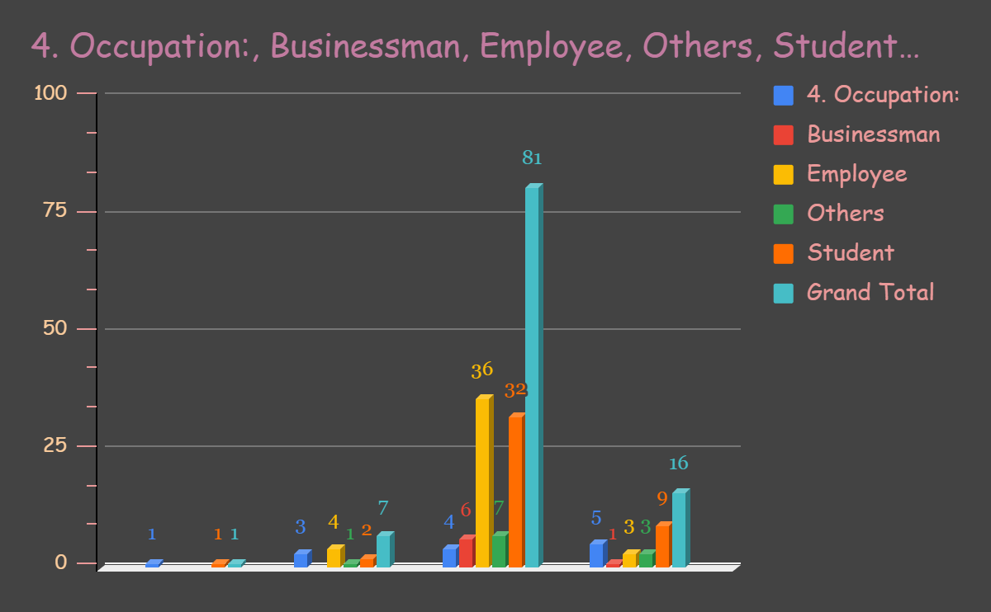

5.17 → CHI-SQUARE

|  |  |  |  |  |
| --- | --- | --- | --- | --- |
| O | E | O-E | (O-E)2 | (O-E)2/E |
| 1 | 7X1/105=0.066 | 0.934 | 0.872356 | 13.2175 |
| 4 | 43X1/105=0.409 | 3.591 | 12.895281 | 31.5288 |
| 1 | 11X1/105=0.104 | 0.896 | 0.802816 | 7.7193 |
| 2 | 44X1/105=0.419 | 1.581 | 2.499561 | 5.9655 |
| 6 | 7X7/105=0.466 | 5.534 | 30.625156 | 65.7192 |
| 36 | 43X7/105=2.866 | 33.134 | 1,097.861956 | 383.0641 |
| 7 | 11X7/105=0.733 | 6.267 | 39.275289 | 53.5814 |
| 32 | 44X7/105=2.933 | 29.067 | 844.890489 | 288.0635 |
| 1 | 7X81/105=5.4 | 0.946 | 0.894916 | 0.1657 |
| 3 | 43X81/105=33.171 | -30.17 | 910.2289 | 27.4405 |
| 3 | 11X81/105=8.485 | -5.485 | 30.085225 | 3.5456 |
| 9 | 44X81/105=33.942 | -24.942 | 622.103364 | 18.3284 |
| TOTAL |  |  |  | 898.3395 |

→ DEGREE OF FREEDOM

V=(r-1) (c-1)

=(4-1) (4-1)

=3(3)

=9

DEGREE OF FREEDOM IS 16.919

→ STATEMENT

Hence, the table value is less than the calculated value therefore reject null hypothesis and accept alternative hypothesis.

**CHAPTER-6**

FINDINGS, SUGGESTIONS & CONCLUSIONS

6.1 → FINDINGS:

* 98.3% of respondents use Phonepe app.
* Around 49.6% of the respondents are using phonepe since 1-3 years.
* 2% of respondents are not using phonepe due to various reasons.
* Around 24.3% of respondents use phonepe occasionally.
* Majority of the respondents prefer phonepe to make various payments like bill payments, fund transfer, shopping.

etc;.

* Around 98.2% of phonepe users have tried QR payments.
* 95.7% of the respondents stated that they faced problem while making payments using Phonepe.
* Respondents have face certain problems like technical issues etc;.
* 98.3% of the respondents are satisfied with the services provided by Phonepe.
* Around 90.4% of respondents are aware of other services provided by phonepe.
* 93.9% of respondents say that they will suggest Phonepe to others.
* 72.4% of respondents gave 4 star rating to the phonepe app.

6.2 → SUGGESTIONS:

On the basis of our observations, we submit certain suggestions

* As there are 2% respondents who doesn’t use Phonepe, the company must take certain measures to increase it’s customers.
* It needs to improve it’s customer services.
* It must Implement certain policies ensuring that customer’s will have a trust on their company.
* It also needs to increase cash back offers, coupons etc; in order to gain more customers.

6.3 → CONCLUSIONS:

As the technology is rapidly changing people are also interested in using various latest apps.

* Specially after demonetization of Rs.500 and 1000 people started using various apps like phonepe, googlepe, paytm etc;
* In a very short span of time Phonepe has become very famous that everyone has started using the app.
* From the observations we here by conclude that the customers are highly satisfied by the usage of Phonepe.
* It has various benefits but only few customers utilise all the benefits.
* Most important thing about Phonepe is that it is very easy to use, and the customers need to have some basic knowledge about it’s usage

6.4 → REFERENCES:

* **Denis Abrazhevich.” “ Electronic payment systems:a User-centered Perspective and Interaction Design”, Proefschrift.-ISBN 90-368-1948-ONUR 788,2004.**
* **Kaur Manjot, E-Commerce, kalyani Publication, New Delhi(2012).**
* **Ailya Izhar, Aihab khan, Malik Sikandar Hayat Khiyal, 4Wajeeh Javed and Shiraz Baig”, Designing and implementation of Electronic payment gateway for developing countries”, journal of Theoretical and applied information technology, vol, 26No. 230 April 2011.**
* **Hossein Bidgoli (2002). Electronic commerce. Acadmic press. ED. California: USA**
* **Joseph P.T, S.J (2008) An Indian perspective, 3rd edition, E-Commerce, by PHI learning private limited.**
* **Delali Kumaga Dec 2010 The challenges of implementing Electronic Payment Systems – The Case of Ghana’s E-zwich Payment System**
* **Yang Jing,” “On-line Payment and Security of E-Commerce”. Proceedings of the 2009 International Symposium on Web Information Systems and Applications**

**(WISA’09) Nanchang, P.R China, May 22-24,2009, pp. 046-050**

* **Kolkata Ravi, Electronic Commerce, Published by arrangement with person Education, Lnc and Dorling Kindersley Publishing Inc(1997).**

6.5 → BIBLIOGRAPHY / WEBLIOGRAPGHY

https://en.wikipedia.org/wiki/PhonePe

www.google.com <https://corporatefinanceinstitute.com/resources/knowledge/ecommerce-saas/mobile>

wallet/

https://ideas.repec.org/a/acg/comfin/v9y2021i3p25-29.html

6.6 → ANNEXURE:

1. AGE:

a. Below 18

b. 18-25

c. 25-40

d. 40 and above

2. Gender:

a. Male

b. Female

3. Area:

4. Occupation:

a. Student

b. Employee

c. Businessman

d. Others

5. Do you use PHONEPE:

a. YES

b. NO

6. If YES how long have you been using this app:

a. Below 1 year

b. 1-3 years

c. Above 3 years

7. How often do you use this app:

a. Daily

b. Weekly

c. Occasionally

8. What payments do you prefer to make using PHONEPE:

a. Bill payments

b. Fund transfer

c. shopping

d. All of the above

9. Did you ever try QR Payments in PHONEPE

a. YES

b. NO

10. If YES why do you prefer QR Payments:

a. Convenient

b. Easily available

c. Secure

d. All of the above

11. Did you face any trouble while using PHONEPE for payments:

a. YES

b. NO

12. If YES what type of troubles did you face:

a. Technical issues   
b. Delayed payments

c. Refund issues

d. All of the above

13. Are you satisfied with the services provided by PHONEPE:

a. YES

b. NO

14. Are you aware of other services available in PHONEPE (like Donations , Fastag ,Mutual funds….. etc;)

a. YES

b. NO

15. Do you suggest PHONEPE to others:

a. YES

b. NO

16. How would you rate PHONEPE app on a scale of 1-5:

a. 1

b. 2

c. 3

d. 4

e. 5